## **19. DTP / VTP (Not in Syllabus)**

### **Dynamic Trunking Protocol (DTP)**

* **Purpose**: Allows switches to negotiate the status of their switchports dynamically:  
  + **Access Ports**
  + **Trunk Ports**
* **Default Setting**: DTP is enabled by default on all Cisco switch interfaces.
* **Manual Configuration**: Recommended for security purposes. Use the following commands:  
  + switchport mode access
  + switchport mode trunk

💡 Use the command:

show interfaces <interface-id> switchport

to check a switchport's settings.

**Key Recommendation**: Disable DTP on all switchports and configure them manually for security.

### **DTP Modes**

#### **Dynamic Desirable**

* Actively attempts to form a trunk with another Cisco switch.
* Forms a trunk with:
  + switchport mode trunk
  + switchport mode dynamic desirable
  + switchport mode dynamic auto
* **Note**: If the other interface is set to static access, a trunk will not form, and it will remain an access port.

#### **Dynamic Auto**

* Does not actively try to form a trunk.
* Forms a trunk if the connected switch actively attempts it.
* Forms a trunk with:
  + switchport mode trunk
  + switchport mode dynamic desirable

#### **Trunk to Access Connection**

* Results in a **Mismatched Mode**.
* This configuration is invalid and will generate an error. Traffic will not work.

### **Mode Compatibility Table**

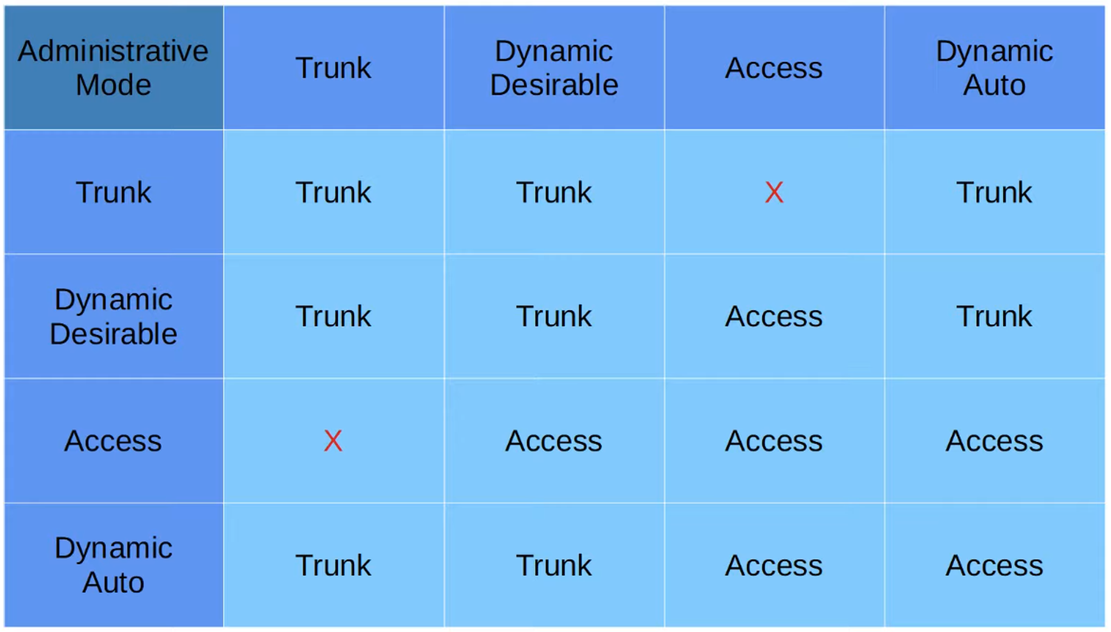

### **Additional DTP Details**

* **DTP does NOT form a trunk** with:
  + Routers
  + PCs
  + Non-switch devices
* **Default Administrative Modes**:
  + Old switches: switchport mode dynamic desirable
  + Newer switches: switchport mode dynamic auto

#### **How to Disable DTP Negotiation on an Interface**

1. switchport nonegotiate
2. switchport mode access

**Security Tip**: Always disable DTP and manually configure switchports as access or trunk.

### **Encapsulation**

* Supported encapsulation types:  
  + 802.1Q
  + ISL

**DTP Negotiation** (enabled by default):  
  
 switchport trunk encapsulation negotiate

* **Priority**: ISL is preferred over 802.1Q.  
  + DTP frames are sent:
    - In VLAN1 when using ISL
    - In the Native VLAN when using 802.1Q (default Native VLAN is VLAN1).

## **VLAN Trunking Protocol (VTP)**

💡 Use the command:

show vtp status

to check VTP status in Privileged EXEC mode.

### **Overview**

* **Purpose**: Configures VLANs on a central switch (server) that other switches (clients) synchronize with.
* **Use Case**: Large networks with many VLANs to reduce manual configuration.
* **Recommendation**: Rarely used and not recommended.

### **VTP Versions**

1. **v1**
   * Does not support extended VLAN range (1006–4094).
2. **v2**
   * Does not support extended VLAN range (1006–4094).
   * Supports Token Ring VLANs.
3. **v3**
   * Supports extended VLAN range (1006–4094).
   * Stores VLAN database in NVRAM (for clients).

### **VTP Modes**

1. **Server Mode**
   * Can add, modify, or delete VLANs.
   * Stores VLAN database in NVRAM.
   * Increments revision number with every change.
   * Advertises the latest VLAN database to clients.
   * Can act as a client to another server with a higher revision number.
2. ⚠️ **Caution**: Connecting an old switch with a higher revision number to the network can overwrite VLAN databases across the domain.
3. **Client Mode**
   * Cannot add, modify, or delete VLANs.
   * Does not store the VLAN database in NVRAM (except in v3).
   * Synchronizes VLAN database from the server.
   * Forwards VTP advertisements to other switches.
4. **Transparent Mode**
   * Does not participate in VTP domain synchronization.
   * Maintains its own VLAN database in NVRAM.
   * Can add, modify, or delete VLANs locally.
   * Forwards VTP advertisements within the same domain.

### **VTP Domains**

* A switch with no VTP domain (domain NULL) will automatically join the VTP domain of any received advertisement.
* If a switch receives an advertisement from the same domain with a higher revision number, it will update its VLAN database.

### **Revision Numbers**

* Resetting a revision number to 0:
  1. Change the VTP domain to an unused one.
  2. Switch to transparent mode.

### **VTP Version Configuration**

💡 Use the command:

(config)# vtp version <version-number>

to set the VTP version. Changing the version will force an update across all connected switches.